 | Project Design Phase-II
 | Data Flow Diagram & User Stories
Date | 05 October 2022
Team ID | PNT2022TMID12583
Project Name | Exploratory Analysis of Rainfall Data in India for Agriculture
Maximum Marks | 4 Marks

Data Flow Diagrams:

A Data Flow Diagram (DFD) is a traditional visual representation of the information flows within a system. A neat and clear DFD can depict the right amount of the system requirement graphically. It shows how data enters and leaves the system, what changes the information, and where data is stored.

0 – LEVEL DATA FLOW DIAGRAM:

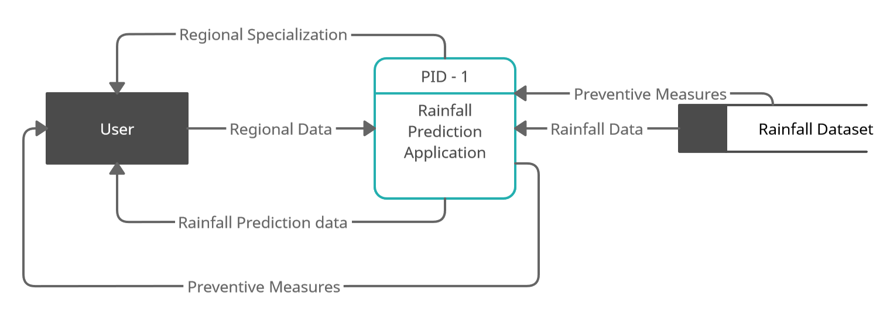

1 – LEVEL DATAFLOW DIAGRAM :

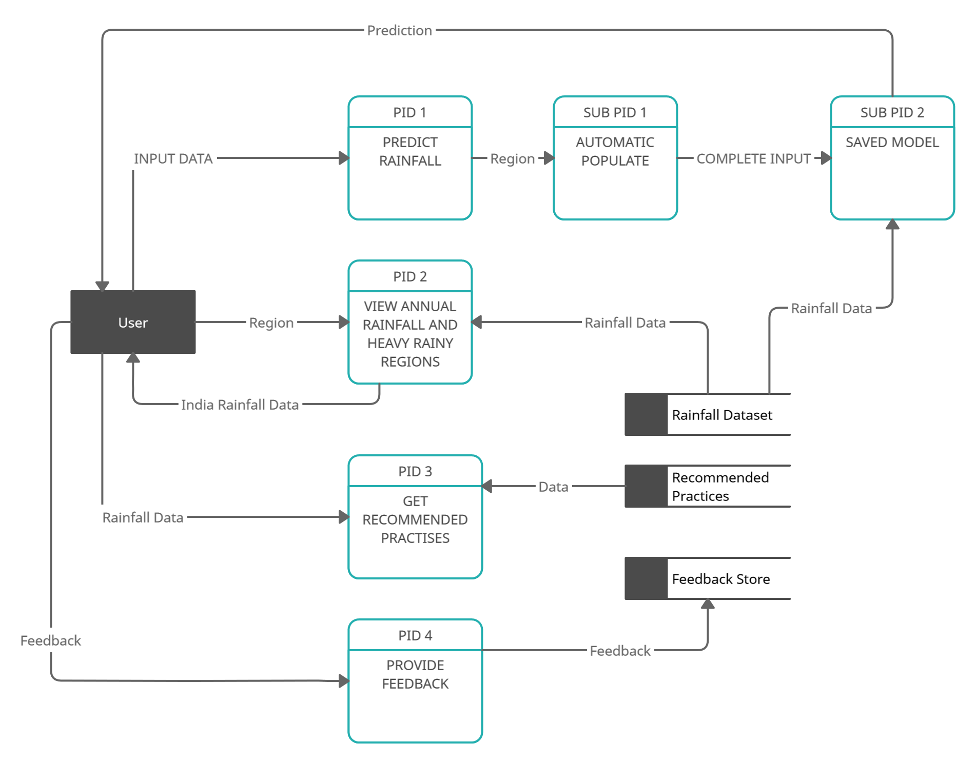

2 – LEVEL DATA FLOW DIAGRAM :

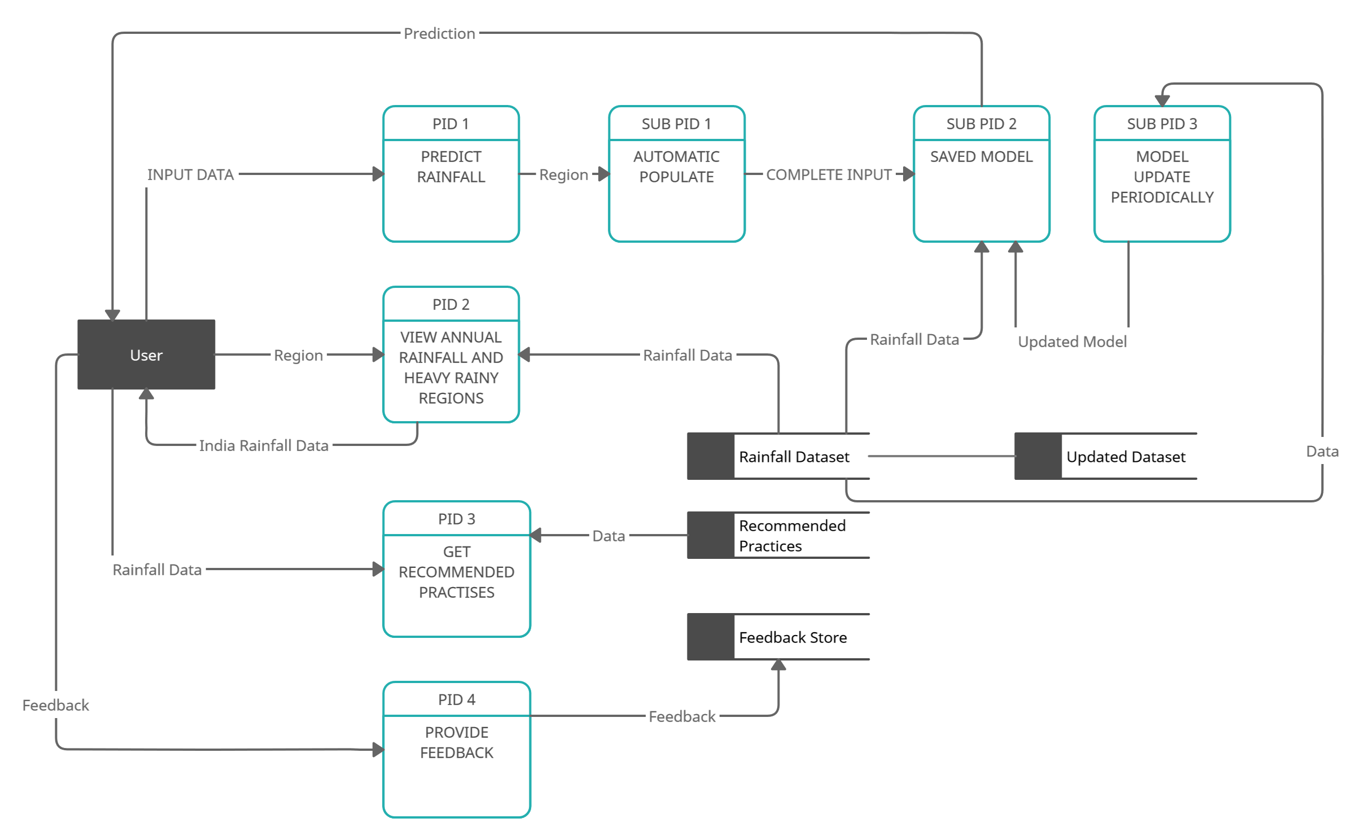

User Stories

Use the below template to list all the user stories for the product.

User Type | Functional | User Story | User Story / Task | Acceptance criteria | Priority | Release
 | Requirement | Number
 | (Epic)
User in | Input Area | USN-1 | Users can select the region for which they want to predict the rainfall and give their inputs like wind direction, speed etc | User should be able to select any region in India and enter the values | High | Sprint-1
Website
 | Visualisation board | USN-2 | User will be able to view different visualisations of what is the monthly and annual rainfall as pie chart and much more | The visualisations has to be dynamically loaded and charts must be responsive | High | Sprint-1
 |  | USN-3 | User can give the feedback on the accuracy of |  | High | Sprint-1
 |  |  | the prediction and on the user interface
Support Team | Support | USN-4 | Responds to user queries via telephone, | Queries can be raised in | Medium | Sprint-2
 |  |  | email etc. | situation of doubts
 |  | USN-5 | The team must analyse all the queries and try |  | Low | Sprint-2
 |  |  | to debug and make plans so that such queries
 |  |  | wouldn’t be raised again
 |  | USN-6 | Organize for a FAQ session where commonly | The user will get all their | Low | Sprint-2
 |  |  | asked doubts can be redressed by the team | doubt clarified
 |  | USN-7 | The team must respond immediately to the | Queries get resolved | High | Sprint-2
 |  |  | queries based on the priority
 |  |  | The development team must develop websites in such a way that it is easier to add features later | Maintenance and updating is easier | High | Sprint - 3
Developer team | Development of Components and software | USN - 8
 |  |  | Develop Website in responsive manner that fits in for all devices | User experience is good and feels comfortable | High | Sprint – 3
 |  | USN - 9
 |  |  |  | To keep model up to date | High | Sprint - 3
 |  | USN – 10 | Update Models in frequent intervals

